Evolutionary synthesis of photographic artwork using human fitness function derived from web-based social networks
David Oranchak, Roanoke, VA 24018 doranchak@gmail.com
Student; Genetic Algorithms in Search, Optimization, and Machine Learning; Dr. David E. Goldberg, University of Illinois at Urbana-Champaign

Abstract: This paper explores the possibility of approximating the performance of a human fitness function applied to the selection of generative artwork evolved in a genetic algorithm. Traditional generators of evolutionary artwork rely on human interactivity for selection of aesthetically pleasing art from populations of computer-generated individuals. Users of the Web-based photograph sharing site Flickr.com, through interactions with the Flickr.com web site, have produced a large set of high-quality photographs considered interesting or popular by its users. In this paper I describe experiments that exploit this established data set to attempt to automatically gauge the interestingness of generative artwork.
I. INTRODUCTION
The pursuit of generative artwork through evolutionary computing has often relied on human interaction to judge the quality of the generated artwork. This is a slow process relying on human subjects willing to wade through many variations of images generated by an evolutionary algorithm. The techniques successfully produce computer-generated artwork that many people find interesting or pleasing. But such approaches are limited by the tendency for the human subject to experience fatigue during the image evaluation process (Takagi, 2001). The fatigued detachment from the image-selection process reduces the quality of the selections. Human subjects cannot practically perform selections among large population sizes. Human subjects are also limited in the quickness with which they can perform the selection operations, as they are required to manually absorb the qualities of images in the population.

Interactive evolution computation (IEC) is a technique that optimizes systems based on subjective human evaluation (Takagi, 2001). IEC has been applied to generative artwork by evolving populations of images based on user selections. Researchers such as Karl Sims have already shown that there is great potential for evolutionary mechanisms to produce complex artwork with minimal user input and knowledge of internal details (Sims, 1991). His media installation Genetic Images generates 16 images for display on an arc of screens. Visitors perform manual selection on the images that are most pleasing to them. The selected images reproduce and create the next generation of images for selection. A similar technique is employed by J. Huxtable’s (2005) Genetic Art application. The application generates a random mathematical function and creates new variations based on user selections. Other applications using a similar approach are Unemi’s (2003) “SBART” and Jourdan’s (2005) “Kandid”. All of the aforementioned techniques produce interesting images but are completely dependent on human interaction.

The goal of this project is to explore the possibility of reaching a compromise between IEC techniques and non-interactive evolutionary computation techniques. This project attempts to generate artwork that is interesting or pleasing to people, without requiring a person to perform manual selection from the population of individuals. This approach cannot possibly replace the original “human function” with accuracy and precision. However, by removing the human subject, and replacing the human fitness function with a crude approximation, there may be some benefit from the tireless repetition of the computer hardware, capable of relentlessly evaluating larger populations of images in less time.

The experiments described in this paper replace the human function by exploiting quantitative data generated by user activity within the social networking web site Flickr.com. Flickr.com is a popular photograph-sharing website that has hundreds of thousands of registered users. Through the massive amounts of user activity on the website, Flickr.com has developed a proprietary scheme to quantitatively rank the "interestingness" of every photograph submitted to the site. The measurements used to compute interestingness of a photograph include:

- clickthrough rates and origins (user views, and identity of users)
- rates and origins of user-submitted comments
- user-generated tag taxonomies (also called "folksonomies") (Mathes, 2004)
- number of times the photograph was marked as a "favorite" by users.

Given this data set of photographs known to be interesting, we seek patterns of measurable qualities that an algorithm can detect in generative artwork. The fitness function is based on these qualities to encourage production of building blocks that lead to generative artwork of higher fitness. Many such qualities are possible, such as color, texture, composition, subject matter, lighting, size, image features, and so forth. The scope of this paper is limited to color analysis of the images. The color analysis is performed by generating and comparing color histograms representing the color distribution of RGB values in the images.
II. EXPERIMENTAL METHODOLOGY
Reference image selection
Flickr image retrieval is conducted using Flickrj, a Java-based wrapper for the Flickr web API. The wrapper provides many convenience methods for obtaining the most interesting photographs from Flickr over any date range covered by photographs on the site. For a given day, photos considered to be interesting are ranked in descending order of interestingness. This ordering is determined by Flickr. For example, the following hyperlink displays interesting photographs selected from all photographs uploaded to Flickr on January 1, 2006: http://flickr.com/explore/interesting/2006/01/01/. The pool of images used by the genetic algorithm was obtained by selecting the single most interesting photograph each day, over a period of 853 days. From this pool of images, 177 images I considered most interesting were selected as the reference images for the genetic algorithm. Small, medium, and large representations of each image were obtained or created for flexibility during experiments. In most cases, the small representations of reference images were used to maximize population sizes and encourage the most efficient use of memory and computation time. To avoid the unnecessary cost of normalizing histograms for images of different sizes, all images in the reference set are resized to exactly match the height and width of the generated artwork. For experiments creating small images, reference images were resized to 100x75 pixels. For experiments creating larger images, reference images were resized to 320x240 pixels. Figure 1 shows a small sampling of the 177 reference images.
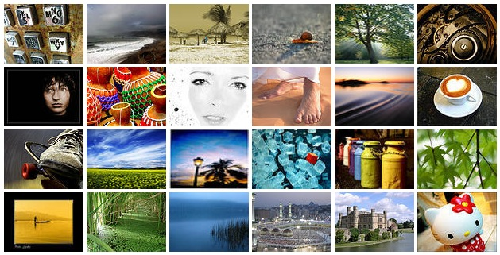
Figure 1: Sampling of the 177 Flickr reference images. View the entire reference image set at the following URL: http://oranchak.com/photosome/flickr/.
Genetic algorithm
Experiments were conducted using two genetic algorithm packages. The first package is JGAP, a Java-based genetic algorithm framework that provides genetic mechanisms and a plug-in system for creating customized genetic operators (Meffert & Rotstan, 2005). The second package is a custom genetic algorithm I wrote in Java to conduct experiments based on J. Huxtable’s Genetic Art application. The JGAP framework required significant and unnecessary overhead to integrate with Huxtable’s application, so the choice was made to hand-code the genetic operators for speed. Each experiment was run in the Eclipse Java IDE on a Macbook Pro running OS X.
Generating artwork
Two techniques were used to generate artwork. The first technique, henceforth referred to as the “Operations technique”, applies a series of rudimentary image operations in sequence to an input image. The type and quantity of such operations creates a large variety of images. Some sequences of operations produce images that do not differ greatly from the input image. Other sequences produce images that completely differ from the input image. Many such sequences result in very abstract and interesting imagery. Table 1 catalogs the types of operations used, as well as the necessary control parameters for each operation.
Operation | Description | Control parameters
Stop | If this operation is encountered, all subsequent operations, if any, are ignored. | None
Invert | Invert (negate) the image | None
Brightness | Increase or decrease the brightness of the image | Percentage [0,100]
Contrast | Increase or decrease the contrast of the image | Percentage [0,100]
Equalize Histogram | Equalize the image using histogram information separately for each color channel | Channel [0 = red; 1 = green; 2 = blue; 3 = all]
Normalize Histogram | Normalize the image using histogram information, separately for each channel | Channel [0 = red; 1 = green; 2 = blue; 3 = all]
Reduce RGB | Reduce the color depth of the image | Number of bits per pixel [2,7]
RGB To Gray Conversion | Convert the image to grayscale | None
Reduce To Bilevel Threshold | Convert the image to a bi-level image by setting all values below a threshold to black and everything else to white | Threshold [0.2,0.5]
Convolution Filter Blur | Blur the image | None
Convolution Filter Edge Detection | Perform edge detection on the image | None
Convolution Filter Emboss | Create an embossed/waxy appearance | None
Convolution Filter Lithograph | Create a lithograph appearance | None
Convolution Filter Psychedelic Distillation | Run a psychedelic distillation filter | None
Convolution Filter Sharpen | Sharpen the image | None
Maximum Filter | Filter operation that replaces each sample by the maximum value of itself and its neighbor samples. | Sample window size. Width = height = [0,27]
Mean Filter | Filter operation that replaces each sample by the mean value of itself and its neighbor samples. | Sample window size. Width = height = [0,27]
Minimum Filter | Filter operation that replaces each sample by the minimum value of itself and its neighbor samples. | Sample window size. Width = height = [0,27]
Oil Filter | Applies a filter that makes the image look like an oil painting. | Sample window size. Width = height = [0,27]
Flip Mirror | Flip or mirror the image | [0 = flip; 1 = mirror]
Rotate Resample | Rotate the image 90, 180, or 270 degrees clockwise | Angle [0=90 degrees; 1=270 degrees; 2=180 degrees]
Shear Resample | Shear an image by the given angle | Angle (-90,90)
Saturation | Change the saturation (hue intensities) of the image | Saturation [0,100]
Value | Change the value (light/darkness of color) of the image | Value [0,100]
Hue | Change the hue (color) of the image | Hue [0,359]
Table 1: Image manipulation operations used to create generative artwork.
Figure 2 demonstrates the effect of successive operations on an input image.
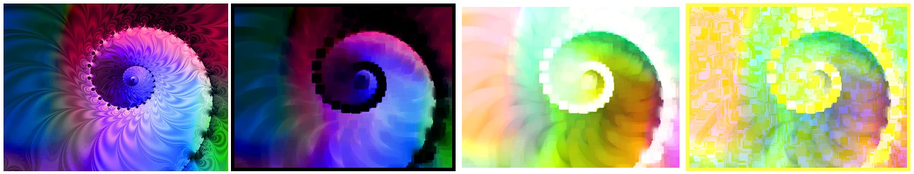
Figure 2: Image operations performed on an input image. From left to right: original image, MinimumFilter applied with window height/width of 11 pixels, Invert applied, NormalizeHistogram applied on Blue channel.
Genotypes for these image operations are represented as sequences of pairs of integer-based genes. The first gene of a pair indicates one of the thirty-one possible image operations. The second gene of a pair defines the control parameters to the image operation of the first gene. The value of this gene is scaled to the acceptable range of values for the corresponding image operation. Gene sequence lengths are varied during experiments to diversity populations.
The second technique, henceforth referred to as the “Huxtable technique”, was implemented as a Java web applet by Huxtable (2005). His technique creates artwork using randomly-generated mathematical functions. A genotype in the Huxtable technique consists of a tree of nodes representing the applications of successive mathematical functions to (x,y) coordinates or constant values. Evaluations and normalizations of these functions are performed, and the resulting function values are mapped to color values to produce images. The technique is similar to K. Sims’ (1991) approach to generative artwork. Figure 3 demonstrates several sample images generated by the Huxtable technique.
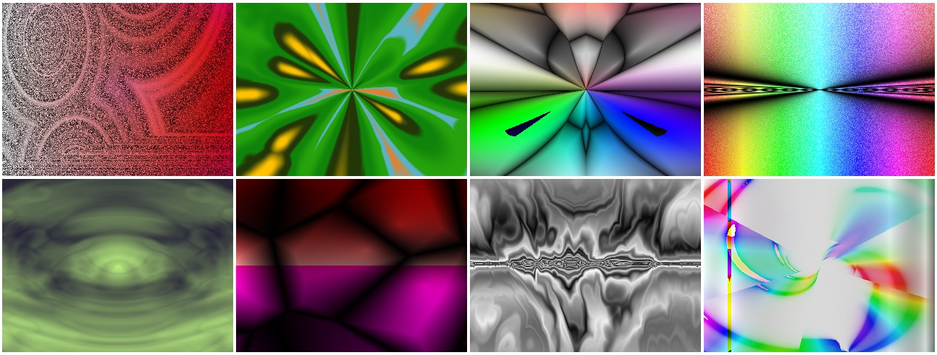
Figure 3: Variety of images generated by the Huxtable technique
A brief, early, and misguided attempt to generate artwork from purely randomized pixel data was abandoned. Selection pressures based solely on color distributions were not sufficient to remove the randomness from the image data. However, I ran a few experiments using randomized images as inputs for the Operations technique.
Fitness function
The fitness of a generated image in a population is computed by creating histograms of color distribution values for the image and comparing them to each of the corresponding histograms for each image in the Flickr reference image set. Three histograms are computed, representing the distributions of red, green, and blue color values; this results in three integer arrays. Each array contains 256 values, corresponding to the RGB color space of the images. The histograms are one-dimensional; that is, they contain only the counts of color distributions for each of the RGB channels. In contrast, a three-dimensional histogram tracks distributions of each of 256³ possible combinations of RGB values. Such a histogram is computationally expensive to use, so one-dimensional histograms were chosen instead. The resulting fitness value is calculated as the minimum Euclidian distance between the three histograms of the generated image and the reference image set. Thus, a lower fitness value indicates a closer color distribution match between the generated image and the reference image. This scheme creates a self-organizing map containing input weight vectors representing histograms of each Flickr reference image. Self-organizing maps have been shown by systems such as PicSOM to be effective at performing content-based image retrieval (Laaksonen, Koskela, Laakso, & Oja, 2000). Generated image histograms are fed into the map, in which the generated images cluster around the Flickr reference image histograms they most closely resemble. Images are compared at fixed heights and widths to avoid the undesired step of performing histogram normalization. The resulting search space size for generated images of size 100x75 is computed as (256³)*100*75, or 125,829,120,000 images. Likewise, the resulting search space size for generated images of size 320x240 is computed as (256³)*320*240, or 1,288,490,188,800 images.
Further experiments replaced the histogram-based fitness function with a fitness function that computes a color count vector of size eight. The elements of the vector consist of color counts for the following color categories: black, red, green, blue, cyan, red, magenta, yellow, and white. A similar self-organizing map is configured to cluster color count vectors of generated images into neighborhoods of Flickr reference image color count vectors.
Operators: Initialization
The Operations technique performs population initialization by randomly generating an integer sequence for the genotype. The length of the genotype’s sequence is varied in different experiments. Also, a few experiments code the genotype by bundling the operation with its operands in a single gene. In this way, genetic operators cannot unlink the operation from its operands. Figure 4 displays the two input images used in most of the experiments using the Operations technique.
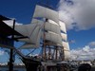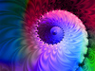
Figure 4: The two input images used in experiments on the Operations technique. Left image is from my personal collection. Right image source: http://flickr.com/photos/jackfrancis/69831563
The Huxtable technique performs population initialization by creating a random subtree of function evaluations. Initially, these subtrees produce fairly simplistic imagery in the beginning of program execution; however, over successive generations, the images become more complex and interesting once the subtree depths increase from the application of genetic operators.
Operators: Mutation / Crossover
The Operations technique performs crossover by selecting two individuals from the population, selecting a random position in the gene sequence, and swapping all subsequent genes for both individuals. Mutation is performed by probabilistically selecting individual genes and re-initializing them with new random values. These operators were selected due to their simplicity, and due to the difficulty in predicting the usefulness of alternate genetic operators on this very large search space.
The Huxtable technique performs mutation probabilistically by traversing the tree of mathematical function operators and changing parameters or the type of a node or by pruning the tree at any point and replacing the pruned part with a new random subtree (Huxtable, 2005). Huxtable’s application does not yet support a crossover operation; I also did not implement one for integration with the Huxtable technique. However, one experiment exploring the effect of an evolutionary strategy approach was performed. In this experiment, a single randomized image is initialized. The nodes comprising the defining function of the image are mutated at various rates until fitness is improved. Once fitness improvement is observed, the original subtree is replaced with the subtree of the mutated image. In this way the effect of gradual improvements is explored.
Operators: Selection / Niching
The Operations technique performs selection using the JGAP class BestChromosomesSelector, which directly selects individuals of highest fitness (lower fitness values) from each population. The number of top individuals to select is configurable and was varied during experimentation.
In both techniques, a niching strategy was employed based on the observation that the fitness landscape includes 177 optimal peaks. Each optimal peak corresponds to one of the 177 Flickr reference images. This observation was motivated by early experiments which demonstrated population convergence on single peaks in the fitness landscape, resulting in marked lack of diversity in the population of generated images. To increase population diversity and produce more improved individuals, a configurable niching period was implemented to control the number of generations between niching operations. In between niching operations, the standard mutation and crossover operations are performed. Fitness evaluation determines the closest-matching Flickr image for each image in the population. Over all generations, a list is kept which tracks the highest individuals on each of the 177 peaks. When the niching period has elapsed, the niching operation is performed, which fills the population with copies of the individuals from the tracking list. This coerces the population to be representative of a larger variety of Flickr reference images. Niching parameters such as niching period and number of distinct Flickr reference images to represent are controlled experimentally.
III. EXPERIMENTAL RESULTS
Approximately 62 experimental runs of the genetic algorithms were performed with the color distribution histogram-based fitness function. Many variations of combinations of the following parameters were performed: population size, image size, number of Flickr reference images, mutation rate, selection rate and scheme (rank selection vs. tournament selection), number and types of image operators (gene length), image operator “perturbation” strength (degree to which image operators alter the input image), niching parameters, evolution strategy (population size of one) vs. genetic algorithm (large population size), randomization of input image pixels, direct mutation of pixel data vs representative gene sequence, niching with generated pixel data vs. gene sequences, passing best evolved individual from the Huxtable technique into the image operations algorithm as an input image, and Huxtable tree max depth. During each experiment, the program saves only the individuals of highest fitness for each best-matched Flickr reference image for each generation. This resulted in over 75,000 generated images. These images were collected into a single set and sorted by fitness across all experiments. Figure 5 displays a small representative sample of several Flickr reference images and their corresponding best-matched individuals generated using the image operations and Huxtable techniques.
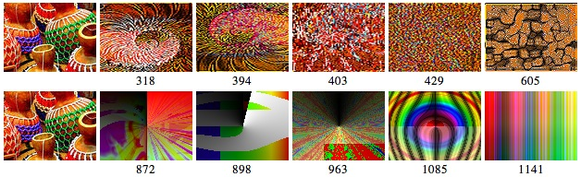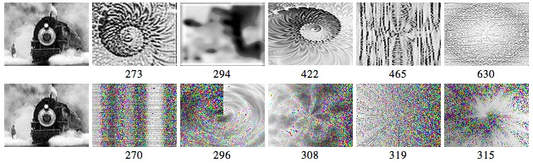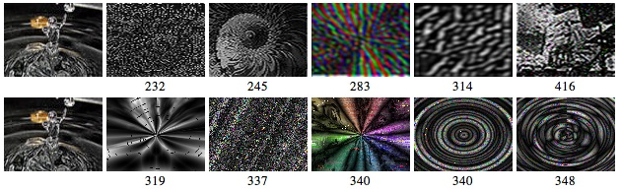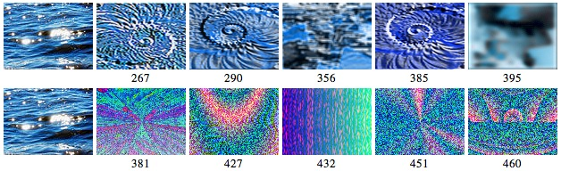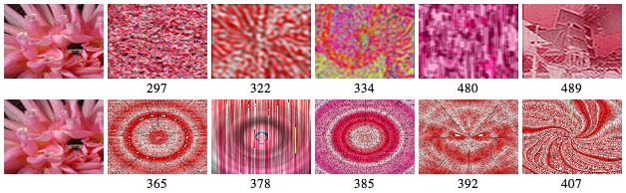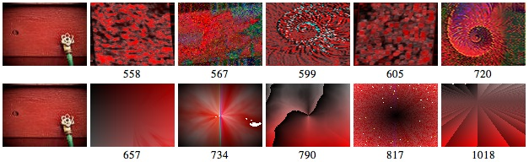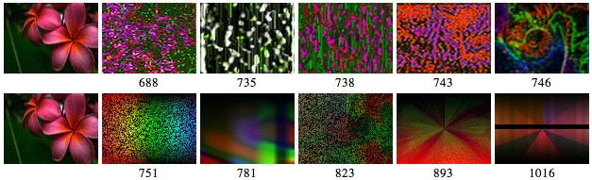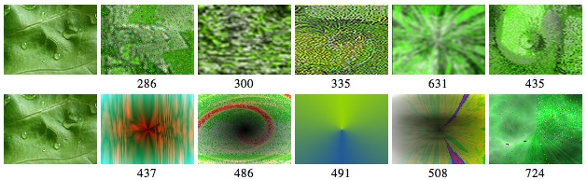
Figure 5: Sample of generative artwork of high fitness, using the color distribution histogram fitness function. The leftmost images are reference Flickr images. To their right are samples of their image clusters. There are two rows per Flickr image. The first row contains images created by the Operations technique. The second row contains images created by the Huxtable technique. Fitness values are displayed under each image. Lower fitness values indicate high-fitness individuals. Most high-fitness individuals contain color distributions that closely resemble their corresponding reference image.
A much larger sampling of all Flickr reference images and their corresponding high-fitness individuals can be found at the following URL: http://oranchak.com/photosome/results.

Results show that the Operations technique produces populations of larger average fitness than the Huxtable technique in most cases. This is likely due to the nature of the image operations – the operations perform a large variety of direct image manipulations. Also, image operations are observed to generate incrementally noisier images than the Huxtable technique.

Reference images with narrow color distributions (such as the mostly black-and-white images in Figure 5) attract the generated images of highest fitness due to the decreased range of color in the reference image.

Color similarities are sometimes more evident in individuals that match reference images that have large regions of non-varying color. For instance, reference images with large black regions are more likely to match generated images that contain large black regions. These regions are easy for a person to recognize. Examples of this effect can be seen here:
http://oranchak.com/photosome/results/1177681-all-index.html
http://oranchak.com/photosome/results/4009048-all-index.html
http://oranchak.com/photosome/results/5861614-all-index.html
http://oranchak.com/photosome/results/650409-all-index.html

Experimentation using the fitness function based on color count vector yields improved results over the histogram-based fitness function. Individuals produced in this way have a larger variety of structures and textures; those individuals of high fitness also have a truer match in color to the Flickr reference images. Figure 6 displays a representative sample of these improved results. The full set of examples of these individuals can be viewed here: http://oranchak.com/photosome/results.

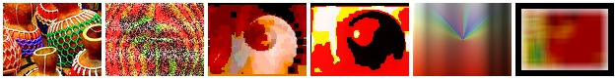
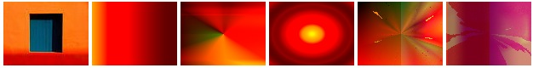
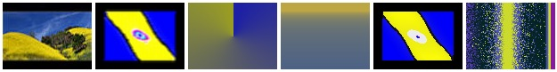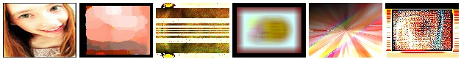
Figure 6: Generative artwork created using the color count vector fitness function in both the Operations technique and the Huxtable technique. Left-most column contains Flickr reference images. More examples, including fitness values, can be seen here: http://oranchak.com/photosome/results.

A weakness of the histogram fitness function is that the one-dimensional histogram color distribution analysis treats each color channel independently when computing color distances for the fitness function. The result is true color distances are not accurately represented. Information about the original pixel is lost. Namely, a true color value in this context is an RGB triplet {r,g,b}, whereas independent color values are compared in the fitness function. Thus, seemingly different color schemes may produce similar one-dimensional color distribution histograms. For example, many of the generated images that match black-and-white Flickr reference images are not black-and-white images. Such mismatched images have one-dimensional histograms that are coincidentally similar to the reference image histograms. To correct this and produce a more accurate matching scheme, a three-dimensional histogram comparison must be performed. However, such a comparison may be computational intensive due to the potential histogram size of 256³ items. Alternative approaches may be useful, such as enhancement of the self-organizing map to match hue, saturation, and lightness values, grid vectors of regional color averages, as well as other color-related measurements.

IV. CONCLUSIONS

The interestingness of generated images is defined by very many factors, many of them subjective in nature. Color distribution is the only objective factor explored in this paper. The techniques herein produce many images that closely resemble the color schemes of reference images that are known to be interesting. With improvements, such as implementing a more precise color histogram matching algorithm, the algorithm will likely produce individuals whose appearance has increased color similarity to reference images. This is not enough to produce interesting images – a randomization of pixel positions of a reference image, which produces a new image having an identical color distribution, will probably generate an image that is not pleasing to the eye. Other techniques must be explored. More rapid convergence may be possible with probabilistic weights added to the operators in the Operations technique (perhaps controlled by a neural network). Combining the color analysis GA approach with other techniques, such as texture analysis, has potential to increase the ability to generate interesting images. Greatly increasing the size of the Flickr reference image set may also improve the effectiveness of this approach. Additionally, re-introduction of a human fitness function at specific times during the execution of the non-interactive algorithm may improve the results. Many of the traditional interactive evolutionary artwork techniques rely on a single user to select individuals deemed to have high fitness. A dramatic improvement to these techniques may arise from the distribution of the human fitness function to online social networks. For example, a web application can present many generated images to a very large number of web users. The users can rank the best images, causing the fitness landscape to be updated by many participants. Resulting clusters of local optima have the potential to increase the value of a generated image’s match to that location of the fitness landscape. Thus the quality of the selection process may be greatly improved.

An incidental ramification or extension of the approach described herein arises when observing that successive image operations resemble actions performed during enhancement of photographs. For example, to improve quality of photographs, digital photographers and artists often use image tools such as Photoshop to manually perform image operations. Some potential exists for such an image tool to automatically produce favorable image operation sequences. This can be attempted by running a similar GA to produce image operation sequences that achieve the closest match to photographs that are known to have desirable image qualities. This may increase the user’s ability to improve the appearance of digital imagery.
V. ACKNOWLEDGMENTS
The following people and projects contributed greatly to this paper:
- Many thanks to Jerry Huxtable for generously giving me a copy of source code for his Genetic Art applet to use for this paper. His applet can be found here: http://www.jhlabs.com/java/art.html.
- The spiral fractal input image is posted under a Creative Commons license by Jack Francis at this URL: http://flickr.com/photos/jackfrancis/69831563.
- The FlickrJ project, maintained by Anthony Eden: http://flickrj.sourceforge.net, http://sourceforge.net/users/aeden.
- The JGAP project, Klaus Meffert and Neil Rotstan: http://jgap.sourceforge.net/
- The JIU project, Marco Schmidt: http://schmidt.devlib.org/jiu/
VII. BIBLIOGRAPHY
H. Takagi, "Interactive Evolutionary Computation: Fusion of the Capabilities of EC Optimization and
Human Evaluation", IEEE Conf. Proc., vol.89, no.9, pp.1275-1296, Sept. 2001.
K. Sims, "Artificial Evolution for Computer Graphics”, Computer Graphics, ACM SIGGRAPH Conf.
Proc., Vol 25, pp.319-328, July 1991.
J. Huxtable, "Genetic Art", [Online document] 2005, Available at:
http://www.jhlabs.com/java/art.html.
T. Unemi, “SBART”, [Online document] 2003, Available at:
http://www.intlab.soka.ac.jp/~unemi/sbart/index.html
J. Jourdan, “Kandid, A Genetic Art Project”, [Online document] 2005, Available at:
http://kandid.sourceforge.net/
K. Meffert, N. Rotstan, “JGAP: Java Genetic Algorithms Package”, [Online document] 2006, Available at
http://jgap.sourceforge.net/.
J. T. Laaksonen, J. M. Koskela, S. P. Laakso, E. Oja, “PicSOM - Content-based image retrieval with self-
organizing maps”, Pattern Recognition Letters, 21(13-14):1199–1207, December 2000.
A. Mathes, “Folksonomies - Cooperative Classification and Communication Through Shared Metadata”,
Computer Mediated Communication - LIS590CMC, Graduate School of Library and Information
Science, University of Illinois Urbana-Champaign, December 2004.

